April 2013

‘UN Global Road Safety Week – every child deserves a safe place to walk’
During April 24 – May 10, 2013 – SKT together with FedEx, CSIP, the United Nations, World Health Organization, Road Safety Directing Center, the Bangkok Metropolitan Administration, Road Safety Partnership agencies, volunteers, and children promoted Safe Roads for children, is part of the United Nations Road Safety Week with ‘Pedestrian Safety’ as the theme. More than 750 participants, including government, non government, NGOs, communities, volunteers, people, children, and media joined the activities to promote walking safety, the activities are as following;

Activities before Global Road Safety Week
- The Long Short Walk - a World Walk for Road Safety The campaign aims to draw attention to the need for child pedestrian safety. The host event team called for volunteers to join the campaign titling The Long Short Walk - a World Walk for Road Safety (More information at http://www.mylongshortwalk.org/) by walking throughout various locations in Bangkok such as Victory Monument, BTS stations, Grammy building, Channel 3 building, and communities. Long Short Walk is a global campaign advocating for safe for roads for all. “Road safety should be the rights of pedestrians and children as being road users.”
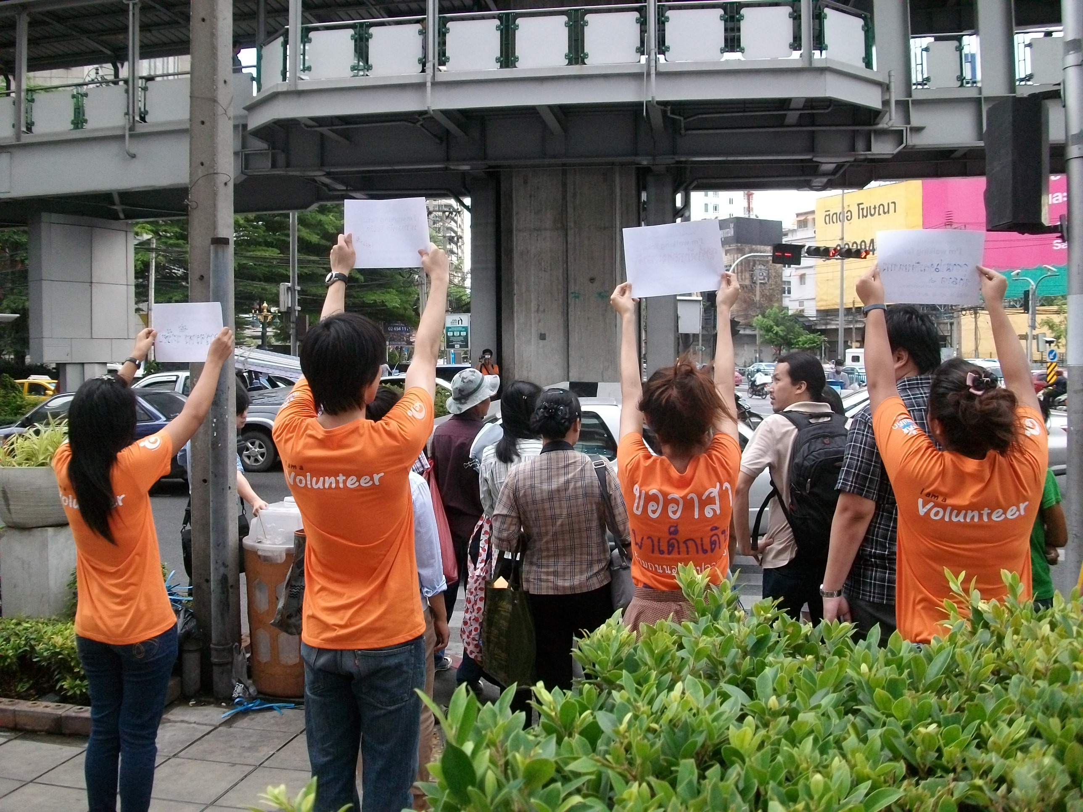 | 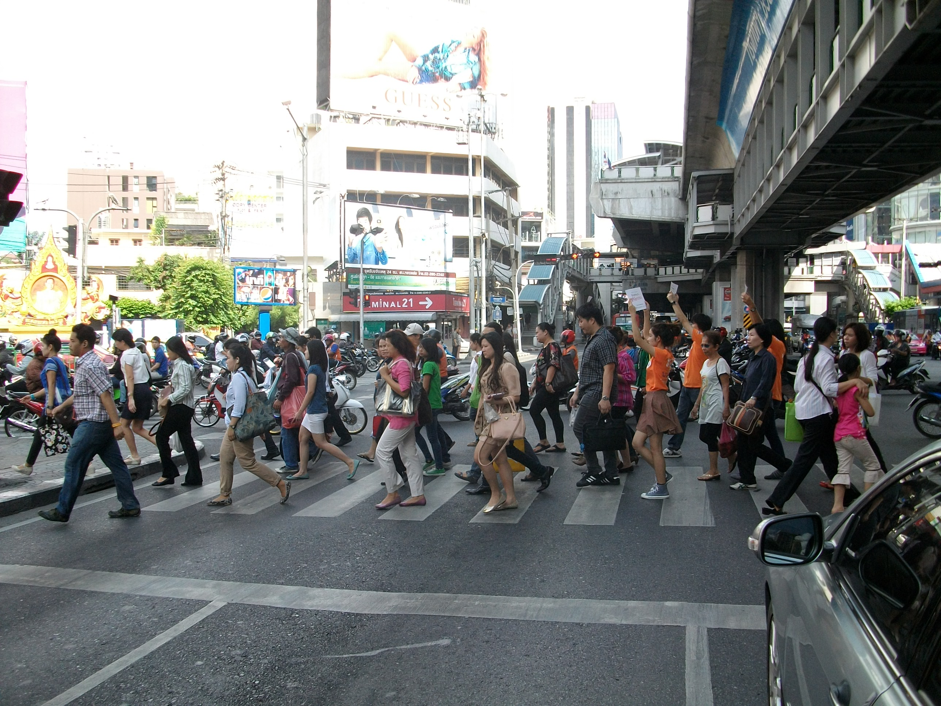 | 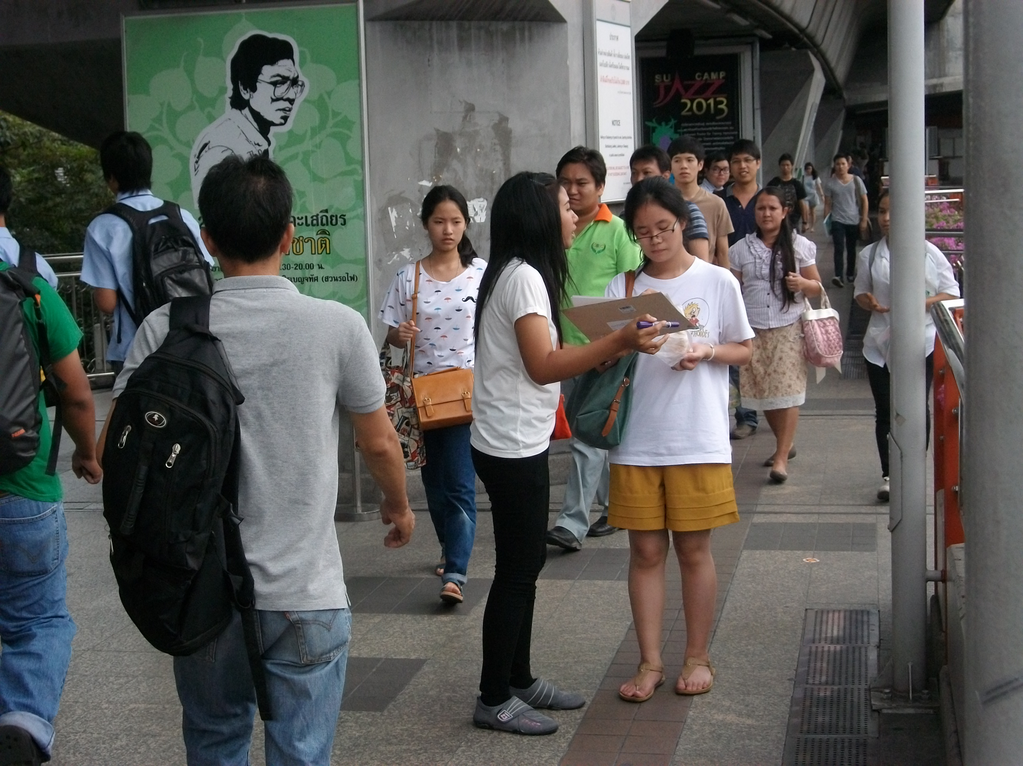

- I'm walking for ...
A campaign celebrating pedestrians in the city.The host event team launched the first-ever pedestrian campaign celebrating walking in Bangkok through awareness, events, and action which received a good feedback from all sectors, both public and private sectors, people, individuals, children and local media by writing down on I’m walking for…statement. During April 24 – May 9, 2013 over a total of 500 statements were collected from all relevant sectors such as government, private sectors, local media, singers, actors, people, parents, children, etc. You can see the Thailand LSW movement video clip at http://www.youtube.com/watch?v=bHHKS1l9SzQ)

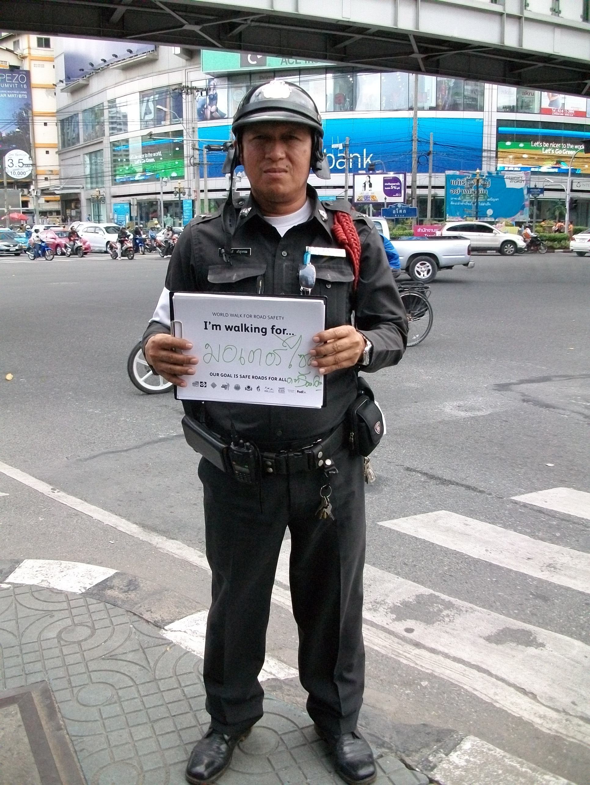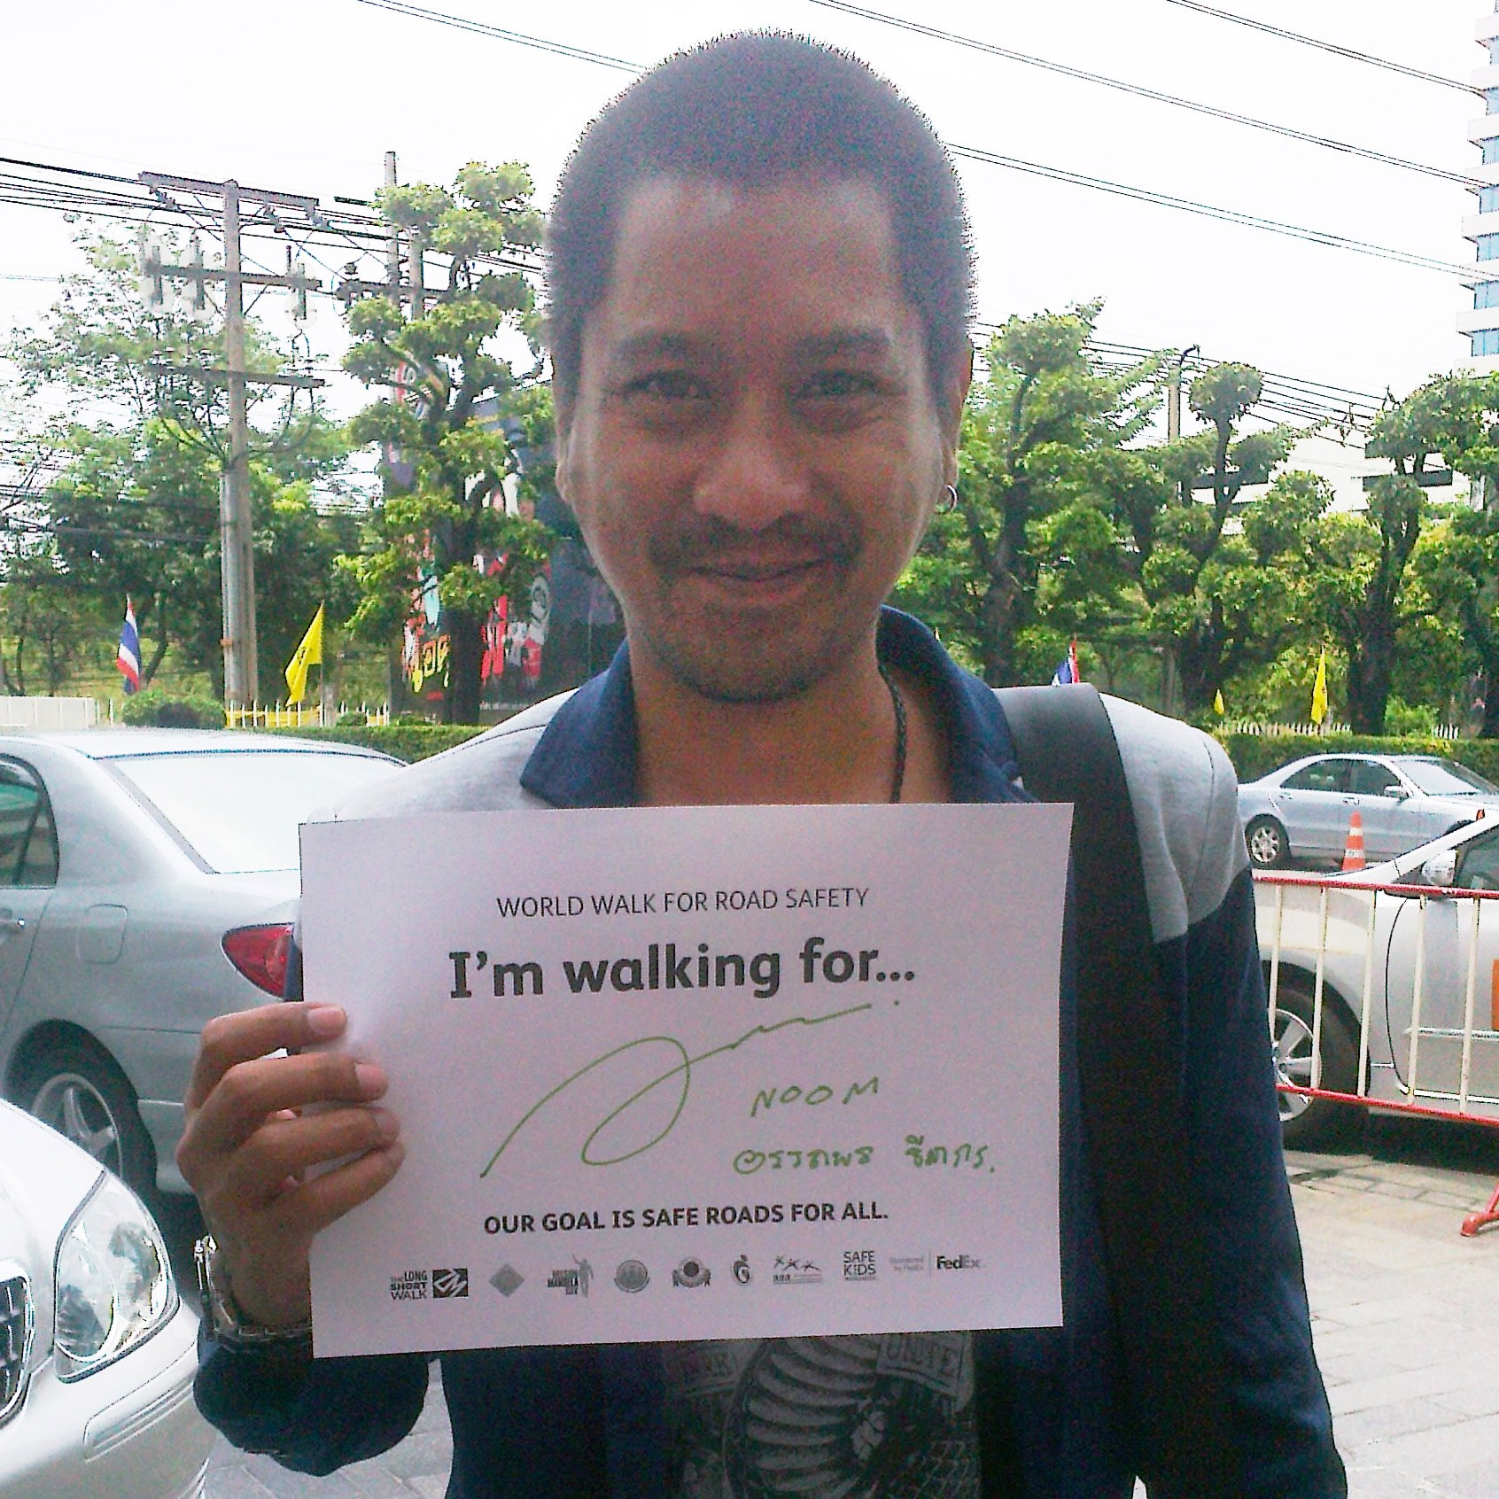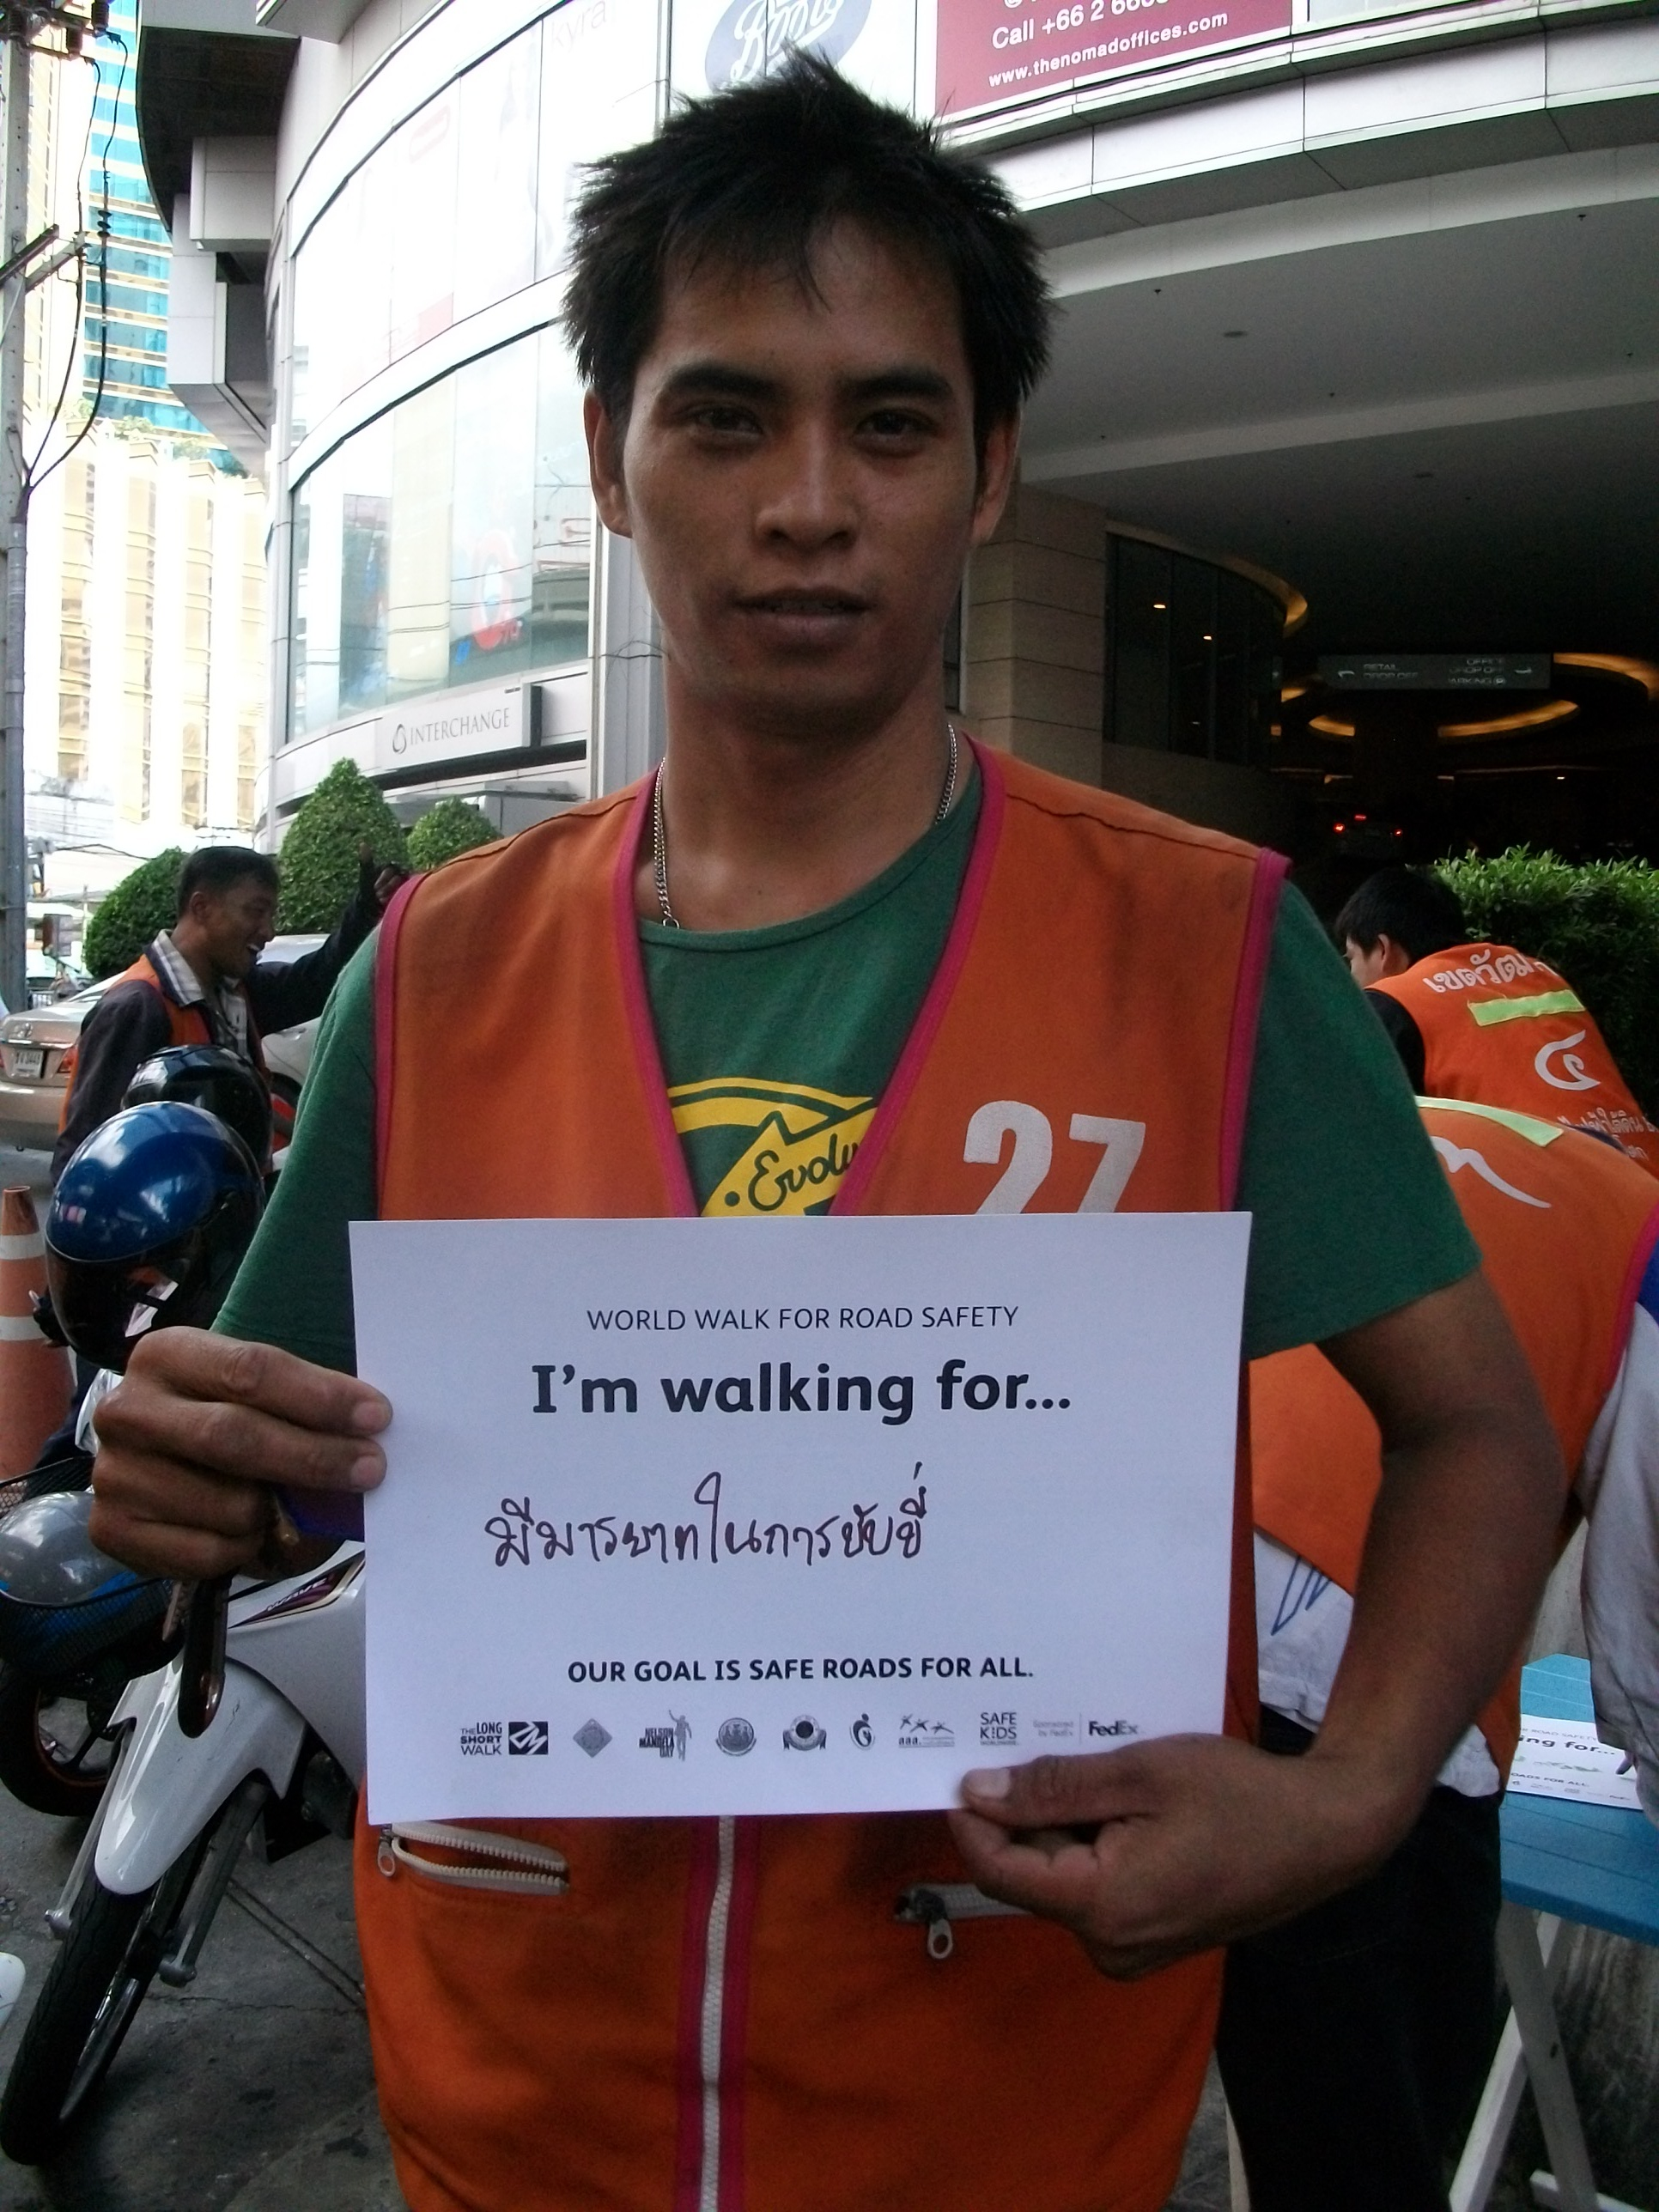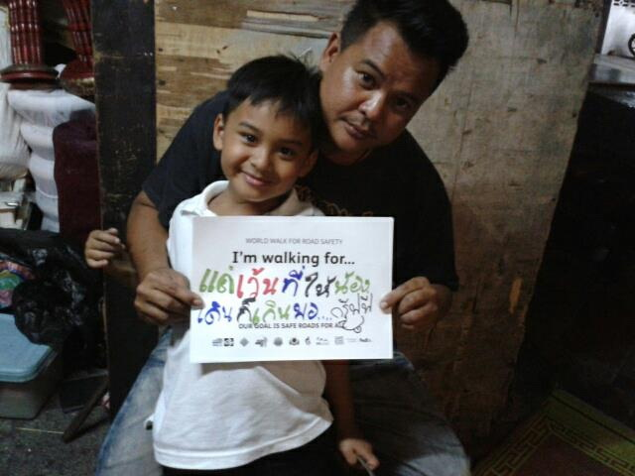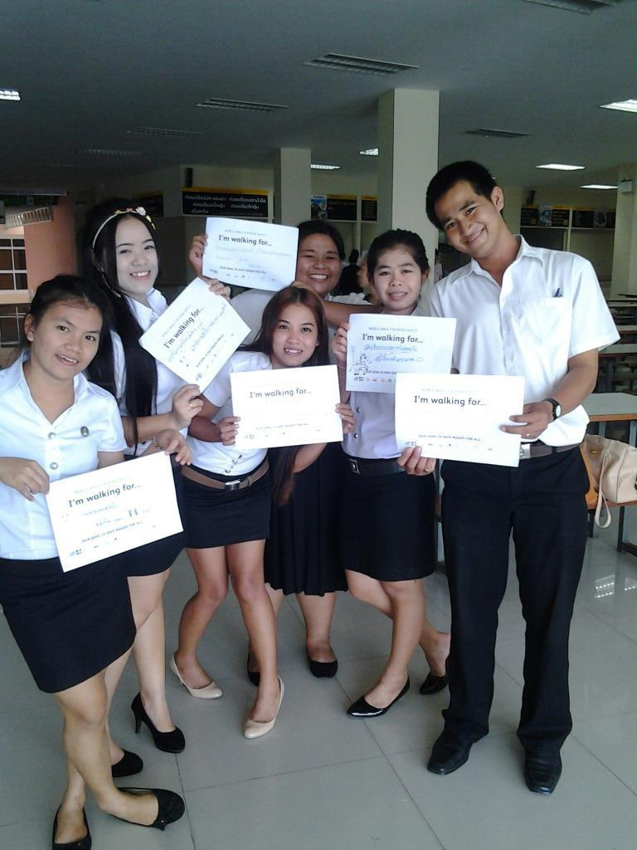
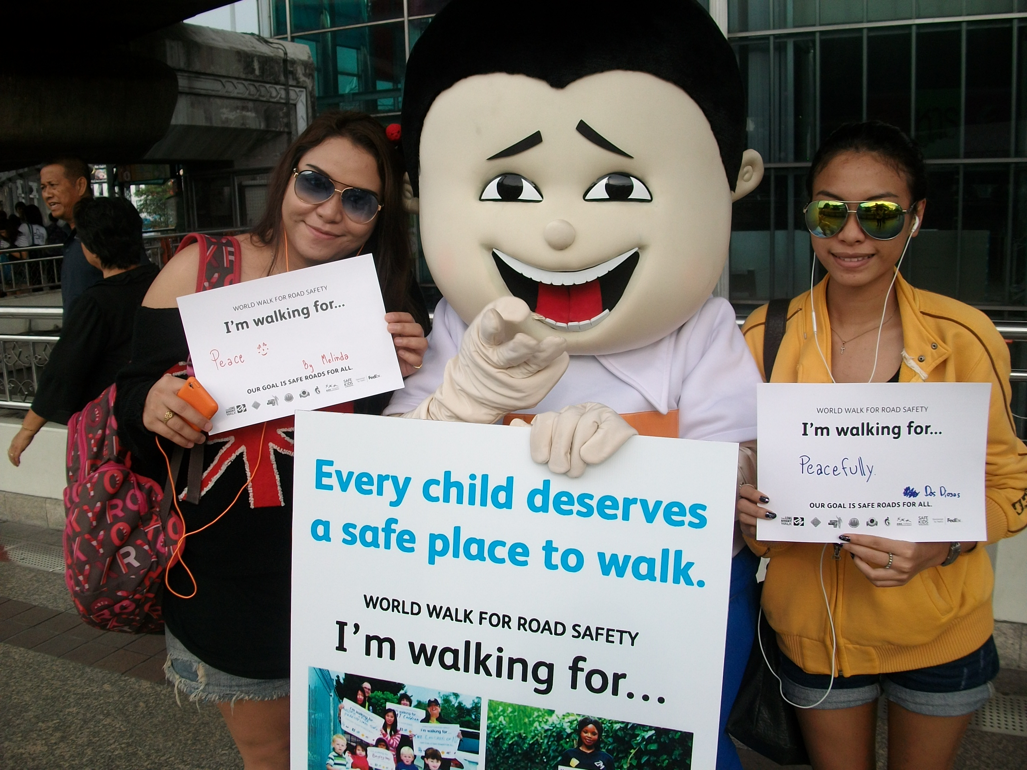

On May 9, 2013, Deputy Bangkok Governor, Pol. Gen. Aswin Kwanmuang had called for a meeting on organizing selling areas for the stalls nearby Khlong Lot and request for a Monday-off selling. Moreover, selling on crossing bridges, corridors or hallways are strictly prohibited. Politician signs also are immediately removed from walkways to the contribution for pedestrian safety. It found a good cooperation from sellers. This measure would continue to other areas such as Pak Khlong Talat, Siam Square, Victory Monument, BoBae Market.

Activities during Global Road Safety Week

- Decade of Action for Road Safety 2010–2020 - Every child deserves a safer place to walk event on May 10 at Suan Saranrom Park, Bangkok with more than 150 participants and 5 FedEx volunteers. Aimed to showcase all the Long Short Walk boards and encourage the stakeholders to have a commitment about their action that could be taken in advance to save child pedestrian lives. The representative from Children and Youth Council of Bangkok delivered the conclusion from 500 statements that most wanted for pedestrian safety could be catagorized into 19 items:
- No shops on footpath / arrange other areas for stalls and shops.
- No Motorcycling on footpath
- Have smooth pavement surface, no pitted pavement.
- Have clean footpath, no garbage, no litter, no waste - - all these may cause an accident.
- Footpath should be reserved for pedestrians.
- Car stop when the child / pedestrian crossing.
- Teach children how to walk and cross the road safely. Adults should be good example as being road users to children.
- Organize footpath and walkway.
- Have police / wardens when crossing the roads.
- Have traffic light or signal for crossing.
- Footpath should have road dividers with clear paint.
- Footpath should be spacious enough for walking.
- Care for child pedestrian and promote road safety.
- Unwant shops on footpath although this is necessary to support sellers’ lives.
- Law prohibits a person walking on the street.
- Unwant beggars or homeless people on footpath or crossing bridge.
- Need more bicycle tracks.
- Notification if footpath and traffic lights were damaged.
- Not play mobile phone / no reading on footpath or when across the road.

The Deputy Permanent Secretary for the Bangkok Metropolitan Administration (BMA), Mr. Sanya Chenimit has announced that Bangkok city is ready to have pedestrian-friendly footpath, in particular for the child pedestrian. Everyone wants to see them grow up happily.



