January 2013

- Teacher Training Workshop
On January 14 and 31, 2013 - SKT conducted the training and evaluation for 50 teachers in Samutprakan Province and Bangkok aimed to increase knowledge among teachers on methods how to teach students about safe road behaviors. And they are now continuing to conduct education and administer pre- and post-tests for their students.

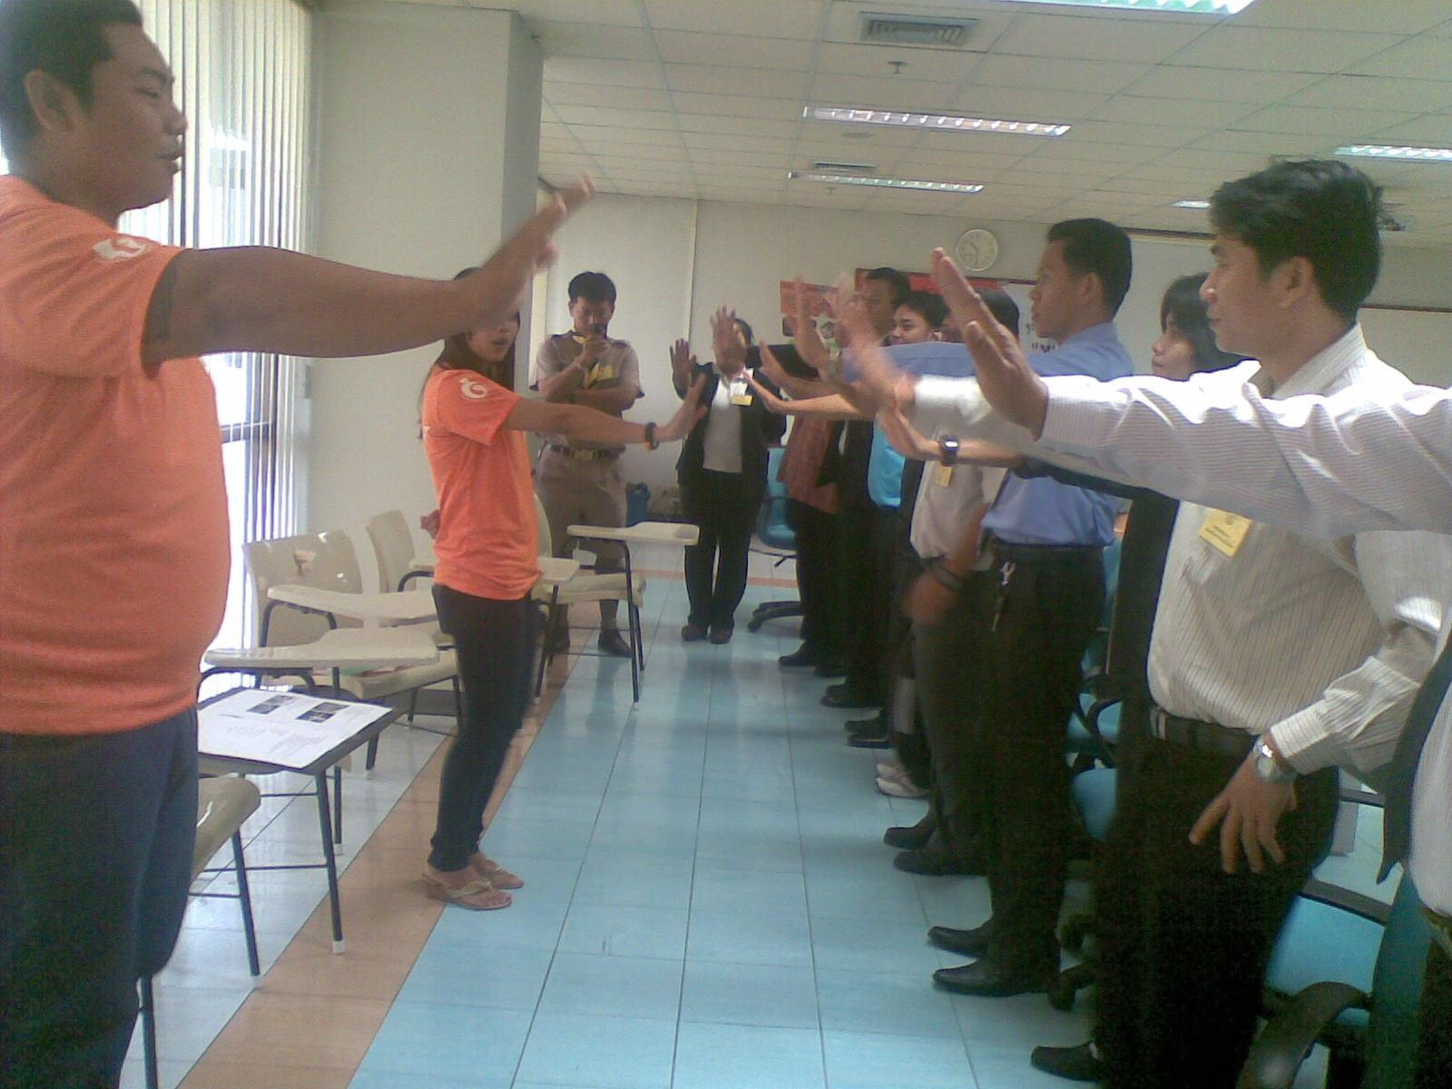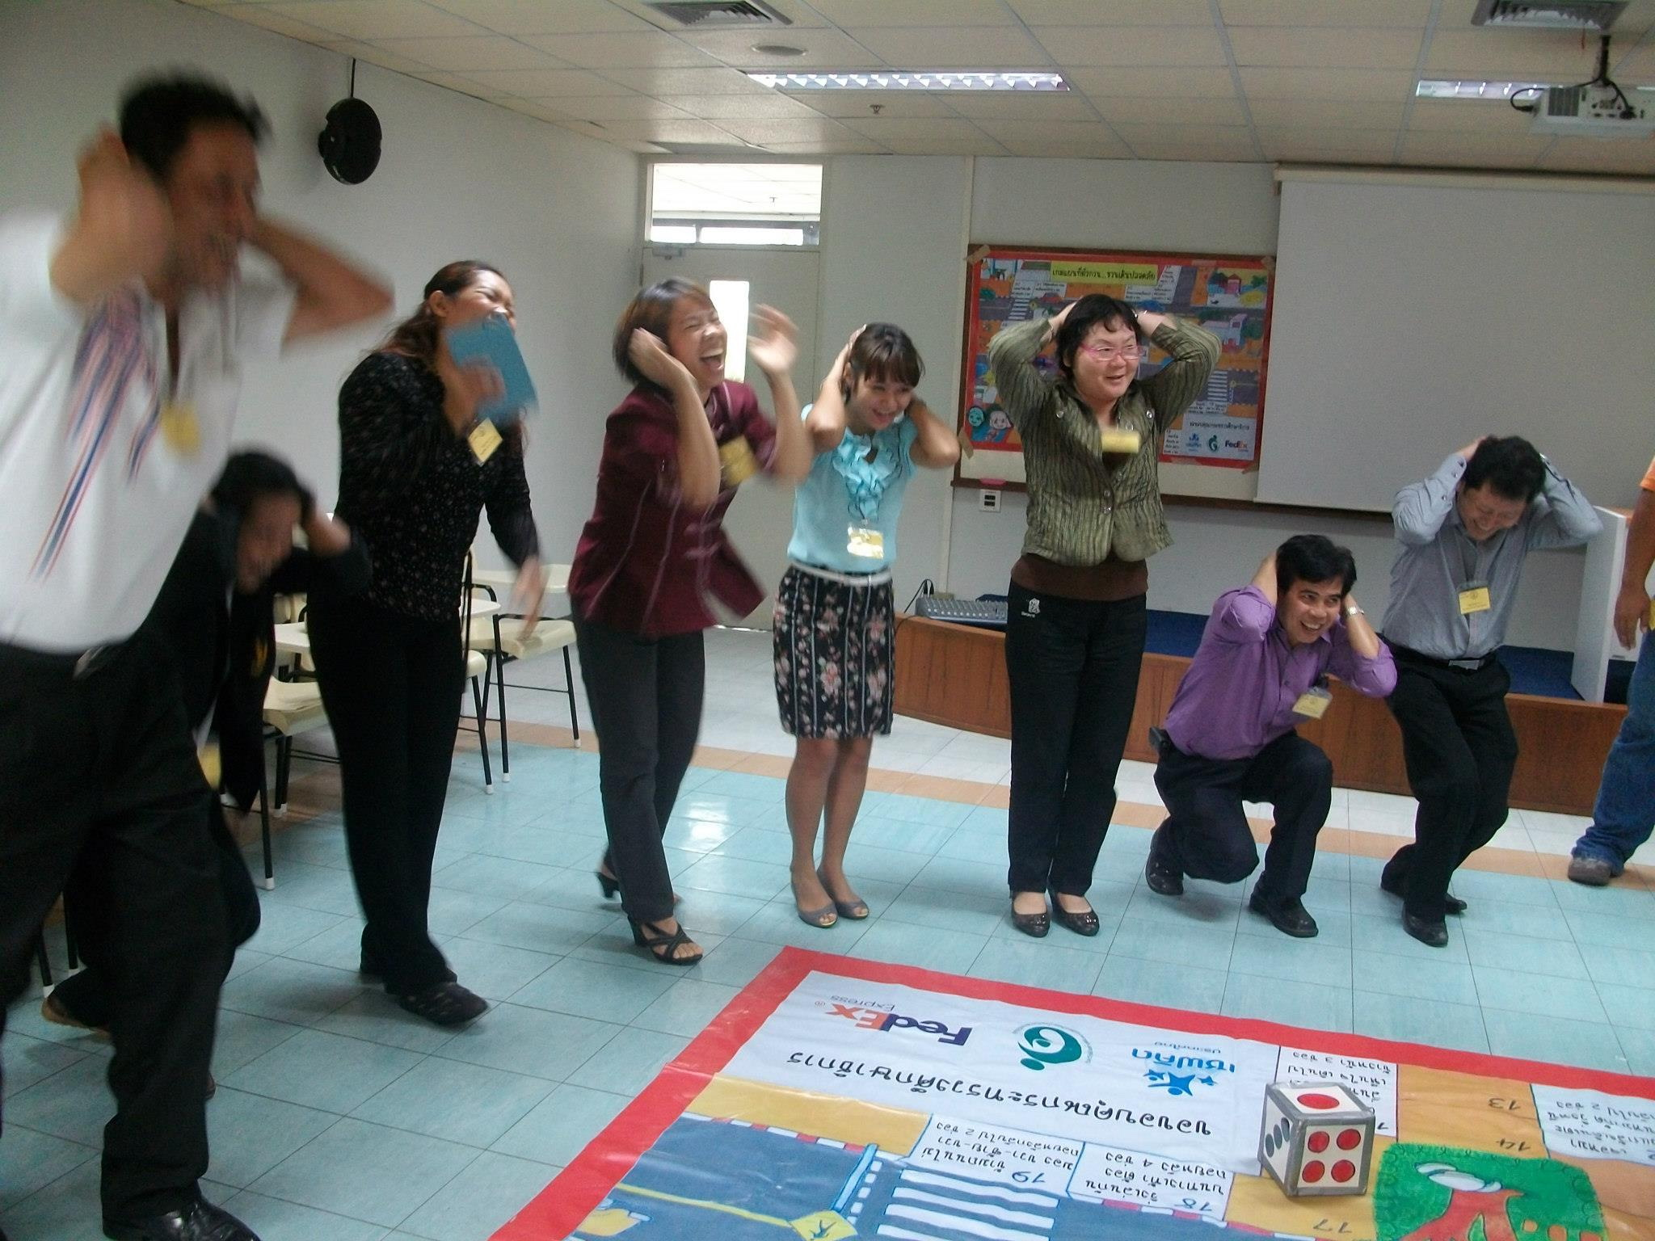

- Meeting with FedEx and Safe Kids Worldwide
On January 28, 2013 - SKT met with representatives from FedEx-Russell Smith and Stacey, Priti Gautam from Safe Kids Worldwide, and the Grayling team.

- The 3rd PHOTOVOICE Exhibition event “How do the adults respond when you see our PHOTO?”
On January 28, 2013 – SKT and FedEx held a PHOTOVOICE Exhibition to display the best 20 photos taken by students to highlight dangerous driving that could result in serious injuries and fatalities among children at Big C plaza, a large shopping mall in Bangkok. The event was attended by more than 180 students, teachers, parents, private agencies, road safety organizations, community leaders, the media, Russell Smith, Stacey Han, volunteer from FedEx and also Priti Gautam from Safe Kids Worldwide. The Exhibition engaged public participation in the selection process for the photo with the strongest child pedestrian safety message by asking visitors to place stickers on photos they believed to be the most compelling. Among the top five winners, the two students received the highest score. And also one special award by FedEx gave to the winning student.



